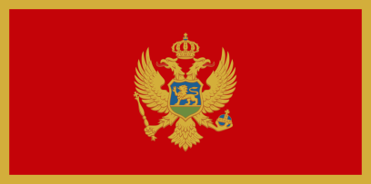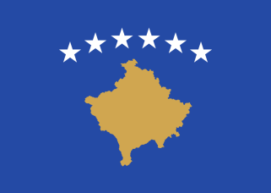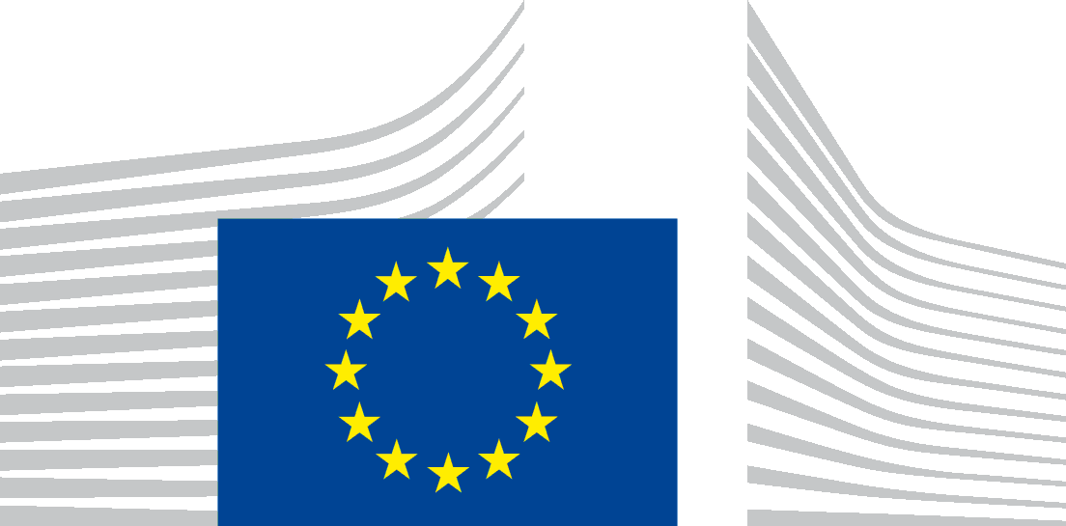

**Call for proposals**

|  |  |
| --- | --- |
| **Cross Border Cooperation Programme Montenegro – Kosovo2014-2020**  **EuropeAid/162-019/ID/ACT/MULTI** |  |

The Ministry of Finance of Montenegro, the Directorate for Finance and Contracting of the EU Assistance Funds is seeking proposals for promoting good neighbourly relations, fostering union integration and promoting socioeconomic development of the border regions in Montenegro/Kosovo,with financial assistance from the „Cross Border Cooperation Programme Montenegro - Kosovo for the years 2014-2020”, financed by the Instrument for Pre-Accession – IPA II. The full guidelines for applicants are available for consultation at <http://www.cfcu.gov.me/en/tenders>and on the following internet site: [https://webgate.ec.europa.eu/europeaid/online-services/index.cfm?do=publi.welcome](https://webgate.ec.europa.eu/europeaid/online-services/index.cfm?do=publi.welcome%20). The deadline for submission of proposals is 15th April 2019, before 14:30 hours local time.

Notice on information session on this Call for Proposals will be published after publishing call for proposals on the website of the Contracting Authority: <http://www.cfcu.gov.me/en/tenders> and on the website of DG International Cooperation and Development <https://webgate.ec.europa.eu/europeaid/online-services/index.cfm?do=publi.welcome> .