Annex 4 – Performance Grant 2019 financed by SIDA

In December 2018, it was decided that the Swedish Cooperation and Development Office - SIDA to co-finance the Performance Grant for 2019 in the amount of € 504,413.00. This amount will be allocated to the eligible municipalities proportionally on the basis of the total grant allocation formula.

The funding sources of the Performance Grant for 2019 are presented below:

Founding Sources of the Performance Grant for 2019

Funding source | Euros for 2019
GoK/MLGA | 950,000
SDC | 1,300,000
Sida | 504,413
Total | 2,754,413

Allocation of the amount of € 504,413.00 for the 19 qualified municipalities for PG 2019 is presented in the following table:

Table 1: Initial allocation – MLGA and DEMOS funds for qualified municipalities

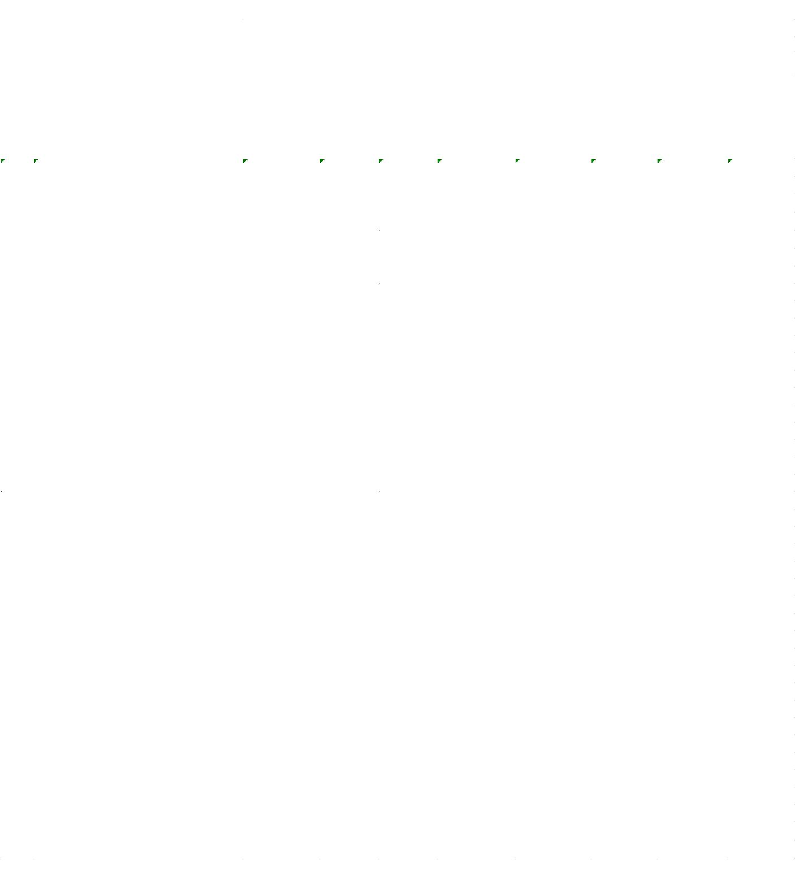
Table 2: Allocation of SIDA funds for qualified municipalities

Table 3: Allocation of MLGA/DEMOS/SIDA funds for qualified municipalities

The total value of co-financing by Sida for three years (2019-2021) is 20,000,000.00 Swedish krona. For the year 2019, the co-financing is 6,716,625.00 Swedish krona, of which 5,457,837.00 Swedish krona will be used for the Performance Grant.
The value of performance grant is calculated taking into account the decimals after the decimal point, although not are all decimals are shown in the table.
The value of performance grant is calculated taking into account the decimals after the decimal point, although not are all decimals are shown in the table.
The value of performance grant is calculated taking into account the decimals after the decimal point, although not are all decimals are shown in the table.

